Maintenance Application Information Document

Ett SAK

Contents

Document purpose . . . . . . . . . . . . . . . . . . . . . . - 3 -
Revision History . . . . . . . . . . . . . . . . . . . . . . - 3 -
ASM Storage Monitoring In Production and Non Database . . . - 4 -

- How to login to OEM Bi Publisher . . . . . . . . . . - 4 -
- Create folder in Bi publisher . . . . . . . . . . . . - 5 -
- Report components . . . . . . . . . . . . . . . . . . - 6 -
- Data Model. . . . . . . . . . . . . . . . . . . . . . - 6 -
- Layout and Report creation . . . . . . . . . . . . . - 9 -
- Report Scheduling . . . . . . . . . . . . . . . . . . - 9 -

Critical or Warning Threshold level. . . . . . . . . . . . . - 11 -

Claim the unused Space . . . . . . . . . . . . . . . . . . . - 11 -

Addding the disk in the Diskroup . . . . . . . . . . . . . . - 12 -

- Check the space Usage of the Diskgroup . . . . . . . - 12 -
- Check the availability of Candidate Disk . . . . . . - 13 -
- Add Disk . . . . . . . . . . . . . . . . . . . . . . - 13 -

Document purpose

The purpose of the document is to describe the Infrastructure process of Länsförsäkringar (LFAB) on PROD and NON_PROD ASM monitoring. It can to be referenced by anyone involved in EttSAK maintenance program to have an overview of the process. This document should be updated only by Infrstructure team to keep it up-to-date with the latest process from the team.

Revision History

Version | Date | Description | Author
1.0 | 2020--02-10 | Initial version of MAID | Ajithraj Thangaraj

ASM Storage Monitoring In Prod and Non Prod Database

Report Generates from OEM BI for all Production and Non Databases and Provides information about ASM storage disk usage:
This Report fetches below mentioned details from Production and Non Production databases
- Target Or Host Name
- Disk Group Detail
- Redudancy Detail
- Total Allocated Size
- Used Percentage
- Usable Total GB
- Usable Free GB
- Imbalance
An email notification will be triggered with all these values and output will be sent as a log file attachment.
Timings – Every Alternate Day Morning At 09:35 A.M.
Job Name – ASM Disk Group Usage Report

We can build query and scheduled the ASM Disk Group Usage Report through OEM BI PUBLISHER by below steps.

- How to login to OEM Bi Publisher

Using Bi publisher applications for all operations on a BI Publisher report such as view, create, schedule, etc..

https://ettsak-oem.lfnet.se:9851/xmlpserver/Enterprise+Manager+Cloud+Control/ASM+Reports/ASM+Space+Report+by+Disk+Groups.xdo

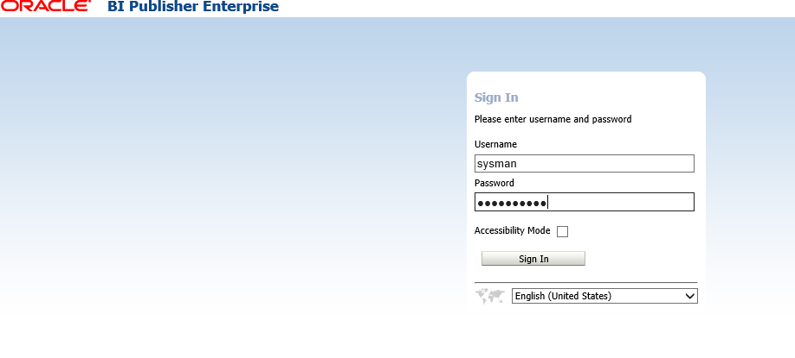

- Create folder in Bi publisher

Use this procedure to create a subfolder within Shared Folder or, if you have the required permissions, create a shared system folder.
- Navigate to the desired location in the Folders pane.
- On the Catalog toolbar, click New and select Folder.
- In New Folder, enter the folder name and enter a description (optional).
- Click Create

Login> Click Catalog>select Folder >click New to create new folder

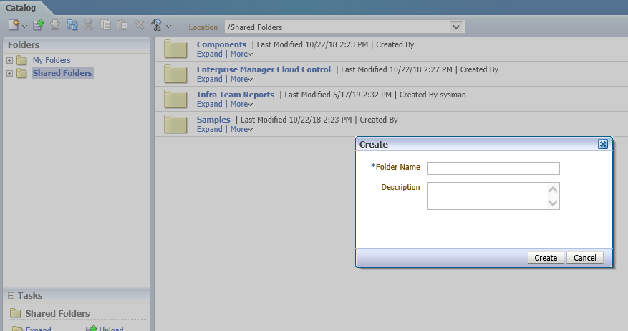

- Report components

- Data Model: A data model defines where data for a report comes from and how that data is retrieved. If a data model can't give you all the data that you need in your report, then you can either copy and edit an existing data model or create a new one. You must be a Administrator to create new data models.
- Layout and report: The layout determines what and how data is displayed on report output Each report has at least one layout template
- Defines the presentation components,such as tables and labeled fields
- Maps columns from the data model to these components so that the data is displayed in the right place
- Defines font sizes, styles, borders,shading, and other formatting, including images such as a companylogo

4. Data Model

- SQL query preparation to get the data.
- We can build the query using Query Builder also.

Click Home >Data model >Data sets >Diagram >sql query

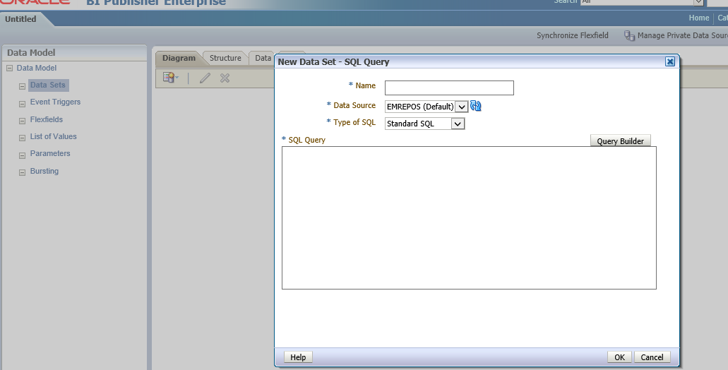

Below find the screenshots of building query using query builder

Column1: Model

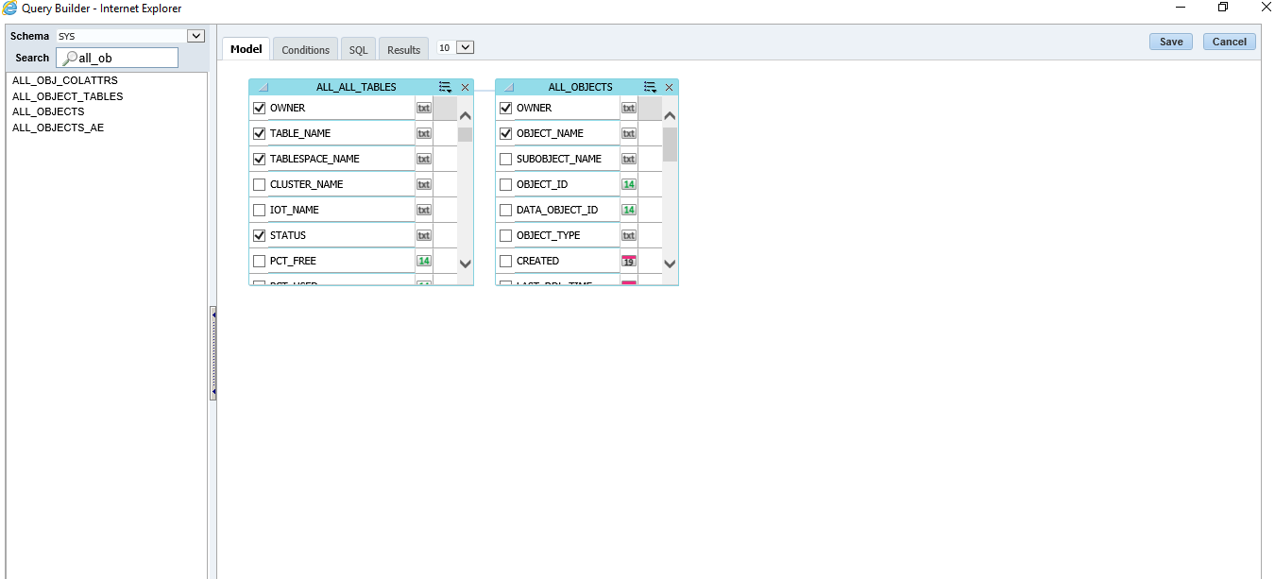

Column2: Conditions

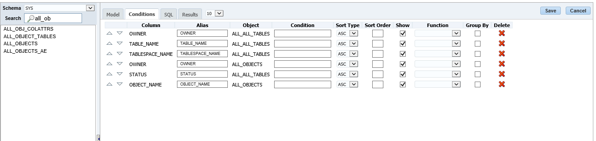

Column3: SQL

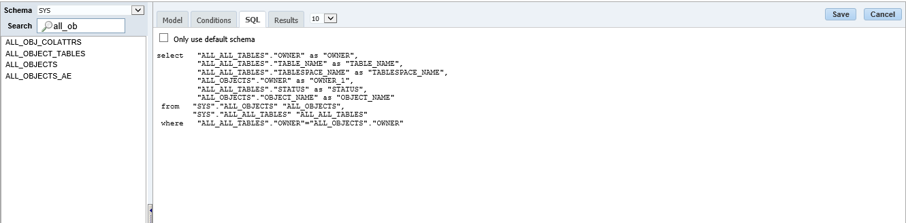

Column4: Results

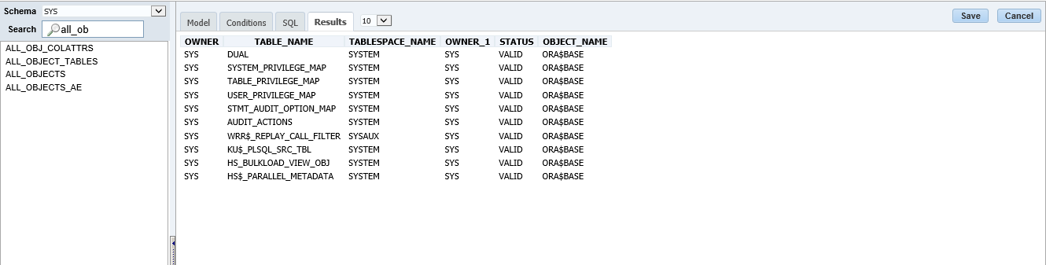

- Save data model
- Data Verification
- Save sample data for report preparation

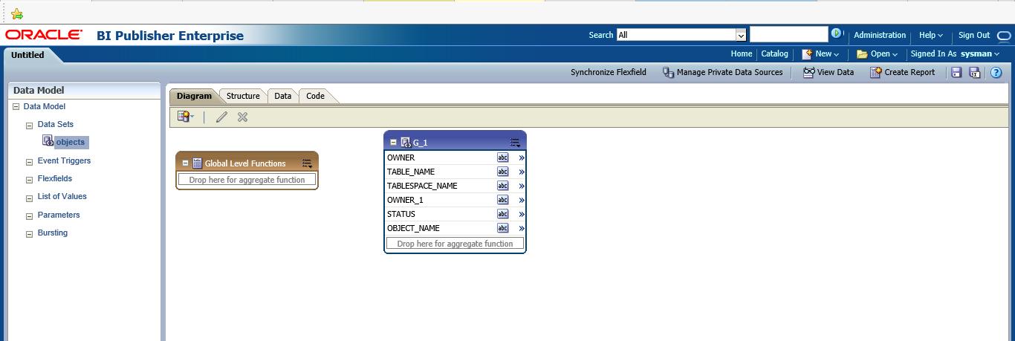

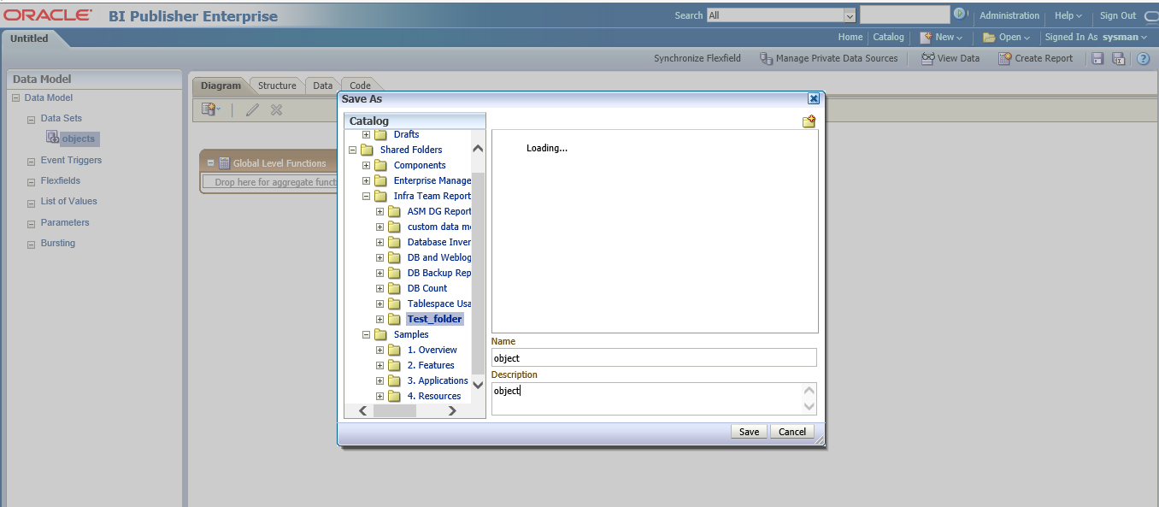
5. Layout and Report creation

- Create Report file under same folder
- Create Report Template

Home >Reports

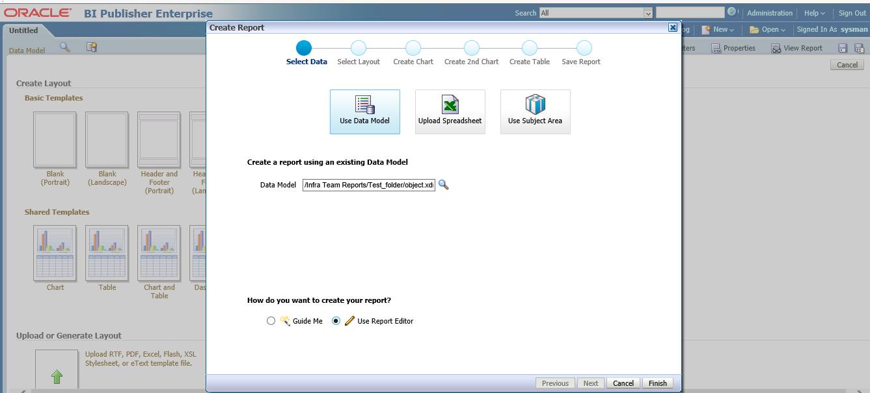

6. Report Scheduling

you can modify the settings for Scheduling the report as per your requirement. Once you are done with all settings, you can either click on “Preview” button to see your report or can click on “OK” button to save it.

An email notification will be triggered with all these values and output will be sent as log file attachment.Please find sample email notification below
Catalog > select folder(where data model stored) >Schedule

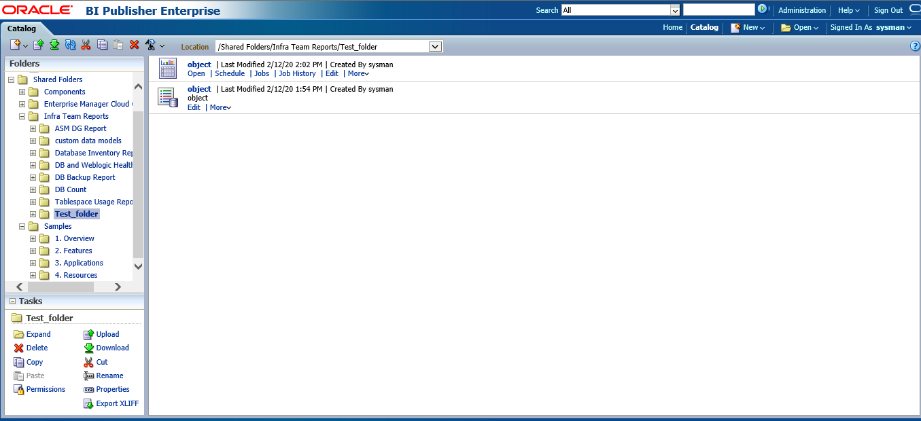

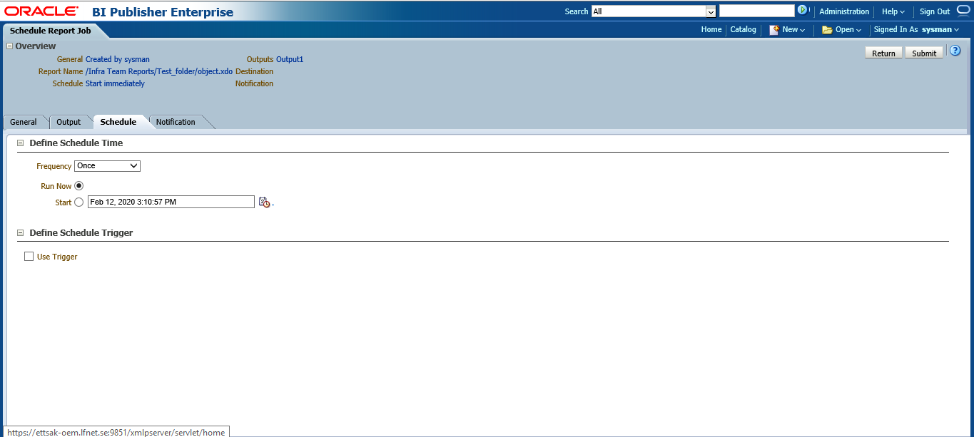
Sample Report

Critical or Warning Threshold level

Alert triggered from OEM once the ASM storage space reaches 80%, In OEM 80% is marked as Warning Threshold level and 90% is markded as Critical Threshold level.

Sample Alert

Claim the unused Space

Once we received the warning or critical alert, we need to check all the tablespace in the Diskgroup for unused space where we can reclaim, so we can reduce the spae usage on the diskgroup.

Use the below command to check the tabelspace space

SELECT tablespace_name, round(size_mb/1024) as ALLOC_SIZE_GB ,round(free_mb/1024) as ALLOC_FREE_GB,round(max_size_mb/1024) as MAX_SIZE_GB,round(max_free_mb/1024) as MAX_FREE_GB,
TRUNC((max_free_mb/max_size_mb) * 100) AS free_pct,
(max_size_mb-max_free_mb)/max_size_mb*100 AS used_pct
FROM (SELECT a.tablespace_name,b.size_mb,a.free_mb,b.max_size_mb, a.free_mb + (b.max_size_mb - b.size_mb) AS max_free_mb
FROM (SELECT tablespace_name,TRUNC(SUM(bytes)/1024/1024) AS free_mb FROM dba_free_space GROUP BY tablespace_name) a,
(SELECT tablespace_name,TRUNC(SUM(bytes)/1024/1024) AS size_mb,TRUNC(SUM(GREATEST(bytes,maxbytes))/1024/1024) AS max_size_mb
FROM dba_data_files GROUP BY tablespace_name) b
WHERE a.tablespace_name = b.tablespace_name) ORDER BY used_pct asc;
SELECT tablespace_name, round(size_mb/1024) as ALLOC_SIZE_GB ,round(free_mb/1024) as ALLOC_FREE_GB,round(max_size_mb/1024) as MAX_SIZE_GB,round(max_free_mb/1024) as MAX_FREE_GB,
TRUNC((max_free_mb/max_size_mb) * 100) AS free_pct,
(max_size_mb-max_free_mb)/max_size_mb*100 AS used_pct
FROM (SELECT a.tablespace_name,b.size_mb,a.free_mb,b.max_size_mb, a.free_mb + (b.max_size_mb - b.size_mb) AS max_free_mb
FROM (SELECT tablespace_name,TRUNC(SUM(bytes)/1024/1024) AS free_mb FROM dba_free_space GROUP BY tablespace_name) a,
(SELECT tablespace_name,TRUNC(SUM(bytes)/1024/1024) AS size_mb,TRUNC(SUM(GREATEST(bytes,maxbytes))/1024/1024) AS max_size_mb
FROM dba_data_files GROUP BY tablespace_name) b
WHERE a.tablespace_name = b.tablespace_name) ORDER BY pc

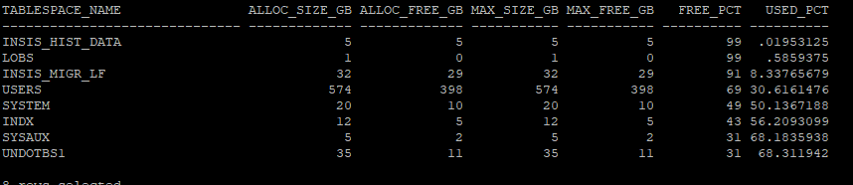

We can use below comman to check the datafiles of tabelspace which have more unused space.

set lines 300
col FILE_NAME format a65
select FILE_NAME, FILE_ID, BYTES/1024/1024/1024 "BYTES GB", STATUS, AUTOEXTENSIBLE, MAXBYTES/1024/1024/1024 "MAXBYTES GB",
USER_BYTES/1024/1024/1024 "USER_BYTES GB", INCREMENT_BY from dba_data_files where TABLESPACE_NAME='USERS';

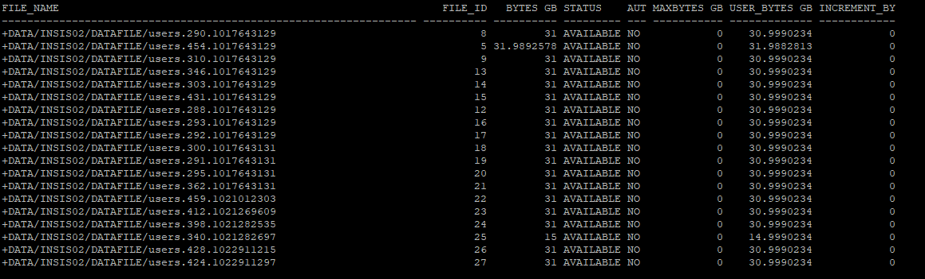
We can use the below command to reclaim the space in the tabelspace which will reduce the space usage in diskgroup.

alter database datafile 18 resize 10G;

Addding the disk in the Diskroup

We need to add the disk to the Diskgroup to suppress the warning or critical alert if enough space is not reclaimed, so we need to follow the below steps to add the disk in the Diskgroup.

Step1 :

Check the space Usage of the Diskgroup
set line 200 pages 9999
SELECT GROUP_NUMBER,NAME,TOTAL_MB/1024,FREE_MB/1024,USABLE_FILE_MB/1024,(TOTAL_MB-FREE_MB)/TOTAL_MB*100 PCT_USED FROM V$ASM_DISKGROUP;

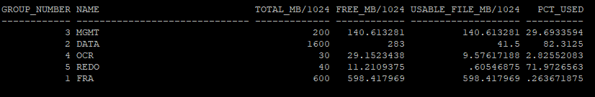

Step2:

Check the availability of Candidate Disk

select GROUP_NUMBER, DISK_NUMBER, HEADER_STATUS, MOUNT_STATUS, MODE_STATUS, STATE, OS_MB, TOTAL_MB, free_mb, name, path from v$asm_disk;

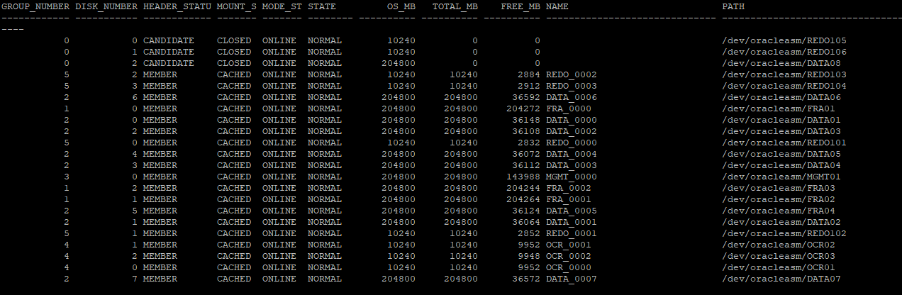

select GROUP_NUMBER,DISK_NUMBER,NAME,path,os_mb/1024,header_Status from v$asm_Disk where header_Status!='MEMBER';

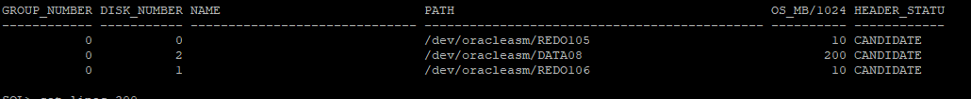

If Candidate disk is not available send mail to HCL Unix team to add the candidate disk as per attached format

Step3:

Add Disk

After checking the availability of candidate Disk, we can add the disk to the Diskgroup using
below command.

ALTER DISKGROUP DATA ADD DISK '/dev/oracleasm/DATA08' REBALANCE POWER 5;

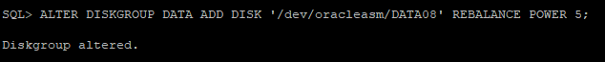

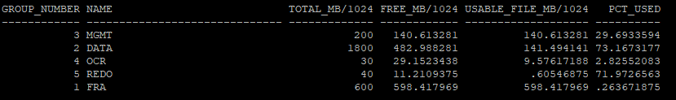

End

